Extract from an 1831 map

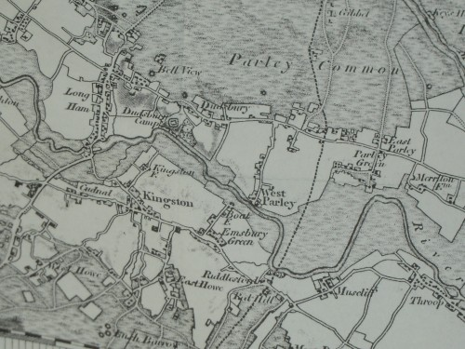

In the second map (below) an attempt has been made to overlay a more recent 1974 map onto the 1831 version. Whilst the maps shows very little change a walk along Church Lane will reveal the developments there in recent times. Nevertheless All Saints still manages to retain the peace and tranquillity (passing jet engines excepting) of olden times. Long may it continue to do so
